


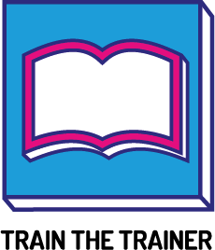

EAL Educational Journey Animations
Created by: Go Higher West Yorkshire | Reviewed 28/11/2019 Next Review date 01/05/2020

Information collaborated by:
Leeds City College
Cockburn John Charles
Coop Academy Leeds

Aims/objectives:

- To provide resource for EAL students to help their understanding of the education system in England
- To eventually provide this resource in a variety of languages that are common in West Yorkshire. This resources in more languages are currently under development.

Links:

- English: https://youtu.be/rkZVYDOzmPM​
- Arabic: https://youtu.be/4CxnqQifq04
- Romanian: https://youtu.be/ttET0ZYx9t4
- Slovak: https://youtu.be/tow0Zu657UA
- Triginya: https://youtu.be/4LVfk2GJEk8

