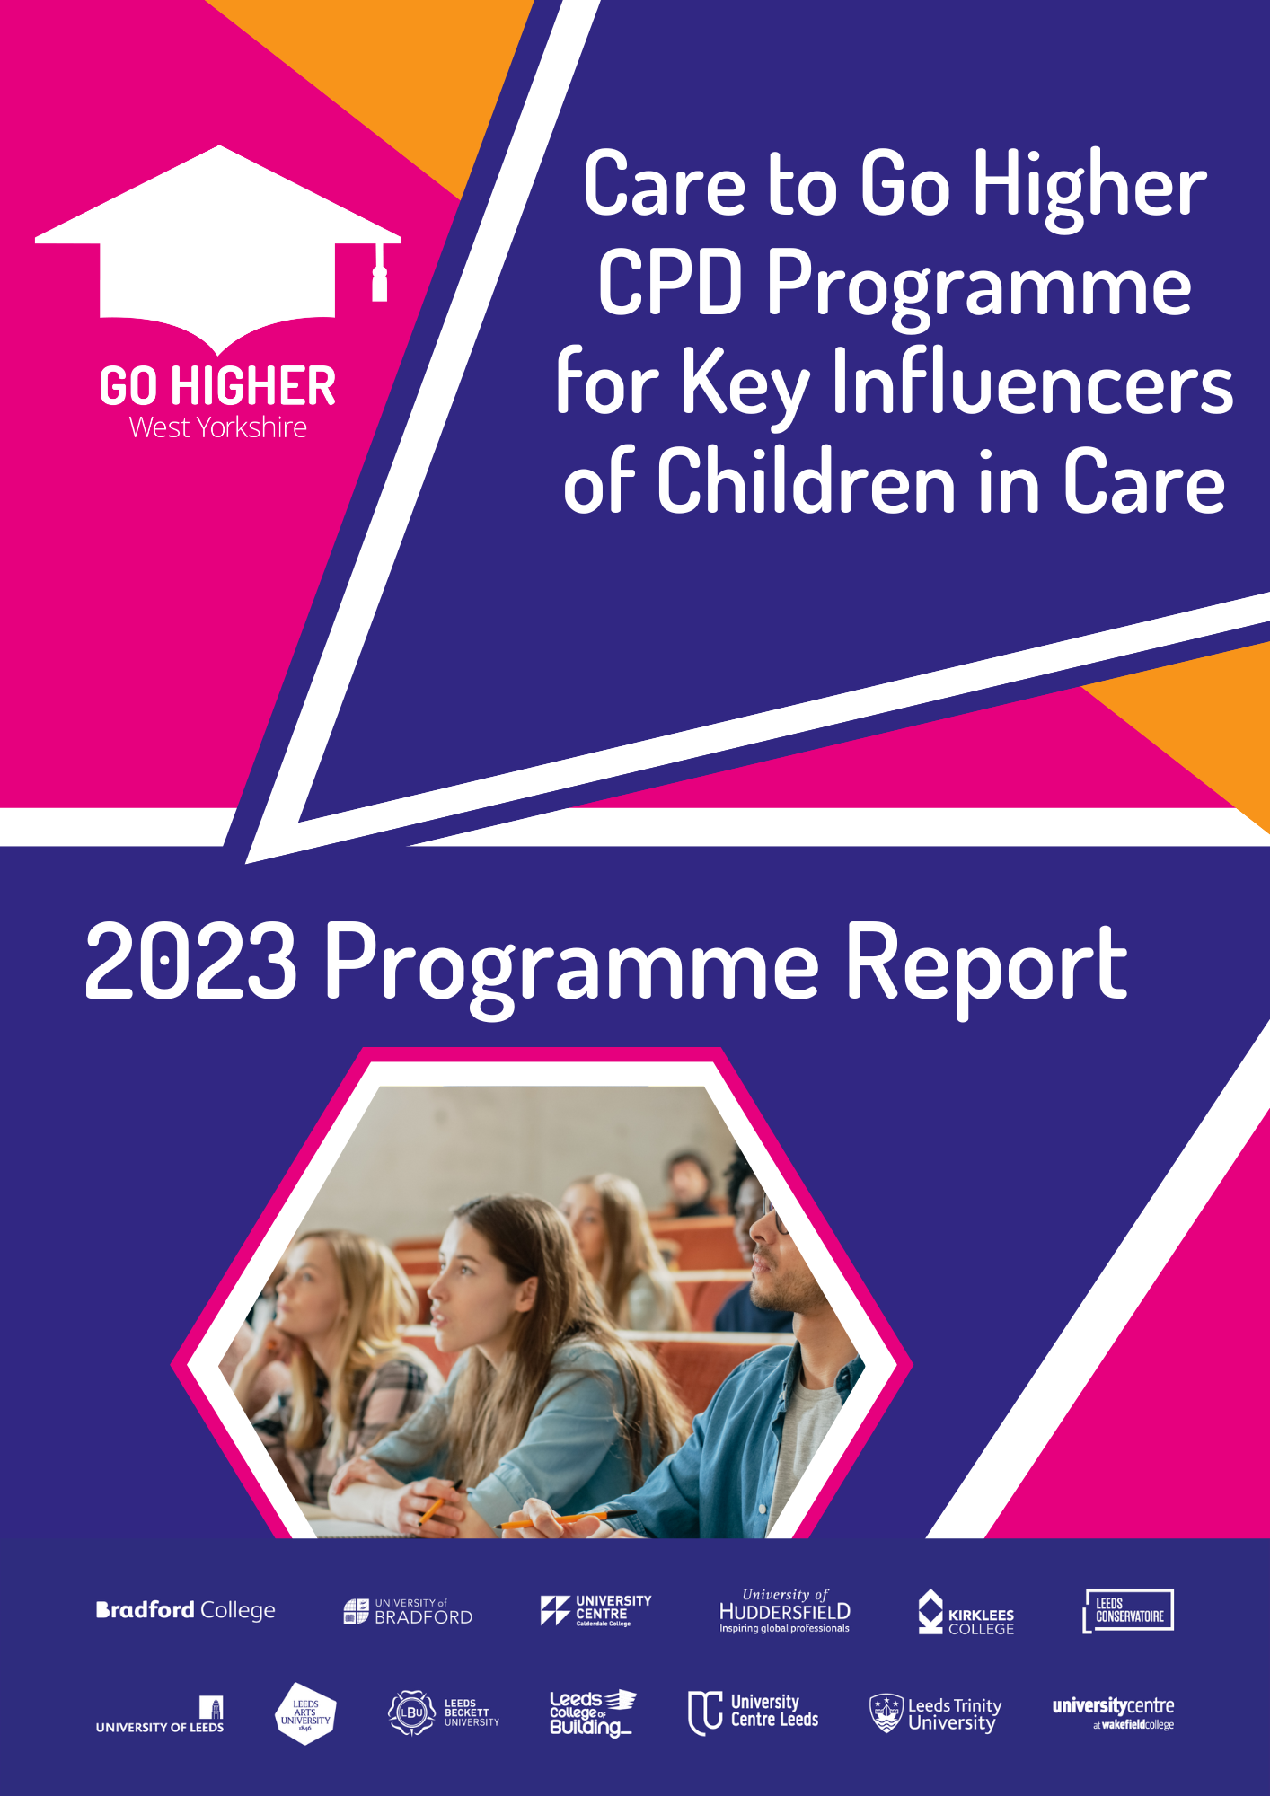

Introduction

The fourth iteration of Go Higher West Yorkshire’s (GHWY) Care to Go Higher (CtGH) programme, which offers CPD to key influencers of care-experienced young people, was held from June to July 2023.

The programme consisted of six two-hour sessions covering a variety of topics. These included challenges faced by care-experienced students, information on Higher Education (HE) providers and styles of learning, and how to support care-experienced students.

Eleven participants graduated from this year’s programme. These were evenly split between foster carers and those supporting care-experienced young people in a professional capacity (e,g, local authority staff, careers advisors for foster care organisations). The programme was adapted between sessions to include information related to the participants’ specific circumstances, so that it was relevant to the challenges they face specifically.

The sessions were delivered virtually, with each one featuring a guest speaker tailored to its topic. These were well received and provided excellent insight to supplement the core programme content. Further details about the guest speakers can be found on page 4.

Each participant was given access to course content and slides after each session, as well as additional links/resources of relevance to the presentation.

Feedback was gathered in the form of quantitative and qualitative data. In addition, anonymous feedback was obtained to ensure the participants were able to voice any concerns. Feedback can be found from page 3 onwards.

The feedback was overwhelmingly positive, with a few constructive suggestions for improvement (read more on page 3). This demonstrates how valuable the programme has been. Feedback from previous iterations was addressed where possible, particularly with regards to the delivery structure. There is nonetheless always room for further improvement.

Delivery Format

The CtGH programme has existed in a variety of formats: in-person, hybrid, and fully online. Each of these was based on learnings from previous deliveries, the need to adapt to online delivery during the Covid pandemic, and making the programme accessible for most of the participants. This has allowed for adaptation of both the structure and the content as needed.

The programme was delivered via six online two-hour sessions, a format that was successfully trialled in 2022. The same session was run twice a week, with attendees able to attend whichever one suited their availability. While participants were encouraged to (and largely did) stick to the same groups, the multiple sessions allowed for some flexibility for those who would have otherwise missed sessions.

For the first time the programme was offered nationally. This helped to meet existing demand and allowed a broader base of participants to benefit from it. There was interest from across the country, with participants being drawn from areas including Cornwall, London, and the Northeast. The increased area allowed GHWY to help support care-experienced students from a wider area. It also increased participant understanding of how much support is available across the country, but specifically in West Yorkshire.

As part of the feedback, participants were asked their opinions about the programme being delivered in weekly two-hour sessions. Unlike previous iterations, where the longer time between sessions was sometimes difficult, the weekly sessions were positively received. The new format, which allowed them to join a different weekly session if they were unable to attend their usual one, was a popular decision. This is evidenced by the feedback below:

“It was great to be able to access the same session twice a week as I was able to switch between two days a week to access one session or the other which was more flexible around my work.”

One participant suggested the programme should be delivered in fewer sessions, with longer time slots to potentially accommodate other commitments, such as the holiday period. However, most participants were content with the existing format.
Guest Speakers

The programme included guest speakers who covered six different topics that aligned with the sessions. These included ‘Raising Aspirations and Supporting Decisions’ and ‘Support Available for Care-Leavers’.

One guest spoke at the end of each session about a relevant subject matter. This reinforced the points made during the sessions and showed how other organisations’ aims can match GHWY’s in terms of supporting progression to HE for care-experienced students.

Each speaker was well received and provided valuable insight into the interaction of the care experience and HE from their own perspective, which was of great benefit to the programme.

The guest speakers, most of whom were from GHWY’s member institutions, were:

- HE Outreach professional – Ian Freedman (Leeds Beckett University)
- Care-experienced students from University of Huddersfield and University of Bradford
- HE in FE representatives – Joanne Tyssen and Laura Macgregor (University Centre Leeds)
- University representative – Chelsea Redshaw (University of Bradford)
- Charity support provider – Helen Arber (Unite Foundation)
- Employability and skills specialist – Nichola Casse (GHWY)

Survey Data Analysis

Participants were asked to complete a series of surveys to help with programme evaluation. There were pre- and post-programme surveys to assess the overall change across the six weeks. In addition, there were pre- and post-session surveys to assess the value of the individual sessions.

The surveys asked participants to rate their understanding of a particular topic on a scale of 1-10, where 1 was little understanding and 10 a strong understanding. Participants had slightly more first-hand experience of HE than previous cohorts. This increased knowledge created the expectation that the baseline and pre-session surveys might have scored slightly higher than in previous years. This was indeed the case, which was noticeable in specific areas. However, there was still improvement in those areas.

The surveys covered a variety of topics related to HE in general as well as the care experience in relation to HE.

Participant responses demonstrated consistent improvement in understanding of key topics throughout the sessions.

Feedback from participants was excellent. As a direct consequence of the programme, one individual took the child they are responsible for to an open day at a GHWY member institution, and another contacted HE institutions to discuss their offer for care-experienced students. This demonstrates that the programme can have both immediate and lasting effects.

Pre- and Post-Session Comparisons

The pre- and post-session surveys related to content included in each session. They regularly showed significant improvement in understanding key topics.

Each session had three questions, all of which showed improvement, often significantly.

Four of the six topics detailed below were some of the most improved areas last year. This year’s attendees had a higher initial understanding of these topics, but the post-session surveys had higher final understanding scores. This demonstrates that the programme still holds value for those with some understanding of HE in general.

Some of the highlights of each session include the below:
Session 1 (38% Increase)
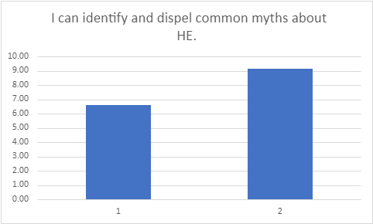

Session 2 (59% Increase)

Session 3 (33% Increase)
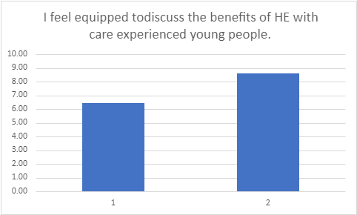

Session 4 (46% Increase)
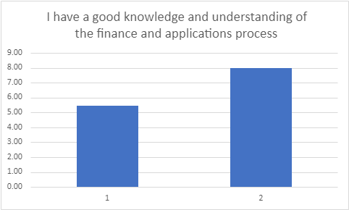
- and Post-
Session 5 (72% Increase)
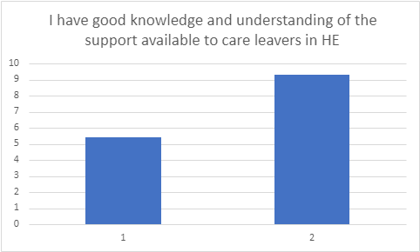

Session 6 (46% Increase)
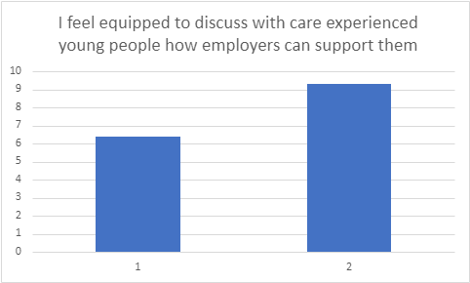

As demonstrated above, the sessions enabled participants to consistently take away the key messages, with large increases in key areas. While each individual question showed an improvement, the average increase was approximately 33% across the session surveys and 48% across the pre- and post-programme surveys. This shows the sessions were consistently of value to the participants, rather than some being more useful than others.

Programme Feedback and Comments

After the programme was completed, participants were asked to provide anonymous written feedback. This ensured impartial responses. The feedback was very positive, some of which is shown below:

I have found the sessions very useful. It has enabled me to formulate a plan and find out what could be offered for LAC [looked after children]. So that they will get the best possible start at university and for the future jobs.

I really enjoyed hearing from Care Experienced young people directly

I have found the sessions really useful and it is helpful that resources are made available to use in the future. It was good to hear from a range of different speakers.

Great training session!

This training was really informative. Dominic [House, Care to Go Higher Delivery Officer] was very knowledgeable and personable. He did well to keep us engaged in the session and the activities were good. I enjoyed learning about supporting care leavers in HE and the wealth of support and opportunities available to them. The additional speakers were good and I particularly enjoyed hearing from them. Also having the opportunity to hear from a care experienced student was great. I would highly recommend this training session.

A really good course presented by Dominic who is very knowledgeable and has a lovely friendly manner. The hard part is remembering all of the information when I am not using it on a daily basis. I will definitely refer back to the slides when needed. I loved hearing from the young people themselves too and hearing their perspective. All in all a really good course although I wasn't able to attend every session due to work commitments which were already in my calendar.

I found this course very helpful and very informative it has opened my eyes to a different prospective of H E. It has also given me a lot of things I hadn’t thought about like what happens after the care leaver has finished their courses.
Future Delivery

Data analysis and feedback suggests the 2023 CtGH iteration was a success, with improvements being made in all survey responses. There are nonetheless lessons to be learned about how to make it even more successful in the future.

This was the first time the programme was delivered to cohorts who live outside West Yorkshire. It is likely that many potential nationwide participants had never heard of GHWY, which meant it was necessary to raise awareness of the organisation as well as interest in the programme. This was always going to be a challenge, however initial inroads have now been made to makie it easier to promote to a national cohort in the future.

For future deliveries we will make use of new contacts that were made during the programme, including participants in professional roles, to promote it to a wider audience. We will also use newly compiled contact details for virtual schools across the country. This will help us to continue offering the programme as widely as possible.

Different areas of the country have different needs and commitments (e.g. school holidays, local authority support). One of the important takeaways from the 2023 programme is that many participants would benefit from more time to prepare for the sessions. As such, the recruitment process will start earlier in the future to allow for planning around the participants’ other commitments. In addition, a longer recruitment period will potentially yield higher numbers of attendees.

With potentially increasing reach, GHWY needs to consider ways to deliver the programme to more individuals. The main consideration is to offer two instances of the programme at different points of the year (e.g. a summer and winter cohort). This is a viable option now that the programme is condensed to six weeks, rather than three or six months like previous iterations.

Programme Expansion

The CtGH programme has now run four successful iterations. In addition to the core programme, GHWY has started to offer alternative delivery methods to target audiences.

The first targeted delivery took place in 2023 working with designated teachers alongside the Wakefield Virtual School. As the programme took place during a busy time of year, teachers’ attendance was expected to be low. As it was a trial, however, this was an acceptable choice.

The programme was condensed into a two-hour session that covered only the most relevant information for teaching staff. As these have more experience of HE than the usual demographic, much of the subject matter discussing HE was unnecessary. The session instead focused specifically on the benefits and support for care-experienced students.

The feedback was positive and initial discussions have started about a second delivery to the Wakefield area’s teachers in the next academic year.

During delivery of the core CtGH programme, some participants mentioned that it would be useful for colleagues in their geographic areas. Initial inroads have been made towards specialised deliveries for Personal Advisors outside West Yorkshire, which is an exciting new opportunity.

Other programme developments are being discussed that will be announced in due course.

Further information

Find out more information about the programme: https://gohigherwestyorks.ac.uk/resources/teachers-carers-advisors/care-leavers/care-to-go-higher/#:~:text=As%20a%20partnership%20of%20West,through%20economic%20and%20educational%20progress

